Battle of X vs O — Project Report
Project Title
Battle of X vs O
Group Members
- Harsh – 24K-0558
- Khubaib-ur-Rehman – 24K-0748
- Aaraiz Nadeem – 24K-0620
Submission Date
23/11/2025

1. Executive Summary
Overview:
This project, Battle of X vs O, is a fully functional Tic-Tac-Toe game implemented in x86 Assembly using MASM and Irvine32 library. It includes two gameplay modes — Human vs Human and Human vs Computer — with a complete AI decision system. The purpose of this project is to demonstrate low-level programming concepts, memory manipulation, decision logic, and procedural organization in assembly language.
Key Findings:
- The game correctly handles grid initialization, human input, decisions, and win/draw detection.
- The computer opponent uses a three-layered strategy:
  - Winning move detection
  - Blocking the human’s winning move
  - Probability-based move selection + random fallback
- The project demonstrates strong use of loops, register manipulation, procedures, modular code structuring, and array indexing in assembly.

2. Introduction
Background:
Assembly language is crucial for understanding how software interacts with hardware. This project allowed exploration of how logic, decision-making, and data structures can be implemented at the lowest level using registers and memory addresses. Tic-Tac-Toe is ideal for this because it requires checking patterns, validating input, and updating a shared memory grid.
Project Objectives:
- Implement a complete game loop in assembly
- Use MASM + Irvine32 for input/output and memory handling
- Implement both Human vs Human and Human vs Computer modes
- Build a functional Decision Based Mechanism using only registers and memory
- Strengthen understanding of procedures, arrays, offsets, and control flow in assembly

3. Project Description
Scope (Included):
- 3×3 grid using a 9-element array
- Human vs Human mode
- Human vs Computer mode
- Computer decision making mechanism with win logic, block logic, and probability-based moves
- User input validation
- Proper grid printing with formatted board display
- Full win/draw detection for both players
- Replay option after game ends
Excluded:
- GUI graphics
- Sound or animations
- Game difficulty levels
- Saving game state to file

Technical Overview:
Tools & Technologies Used:
- MASM (Microsoft Macro Assembler)
- Irvine32 Library (for ReadInt, WriteString, RandomRange, etc.)
- Visual Studio 2022 as IDE
- x86 registers (EAX, EBX, ECX, EDX, ESI) for computation
- Memory addressing (OFFSET, TYPE, array indexing)

4. Methodology
Approach:
- Designed the grid using a 9-cell SDWORD array initialized to -1.
- Implemented grid reset and print procedures.
- Created separate procedures for:
  - Human moves
  - Computer moves
  - Win checking
  - Block logic
  - Probability movement
- Developed turn-based game loops for both modes.
- Integrated input handling and validations.
- Modularized code into procedures for clarity.
- Conducted multiple test runs to ensure correct win/draw detection.

Roles & Responsibilities:
- Harsh (24K-0558) - Developed the Human vs Human mode
- Khubaib-ur-Rehman - Developed the Computer vs Human mode
- Aaraiz Nadeem - Responsible for validation logic

5. Project Implementation
Design and Structure
The program is structured into the following major sections:
- Main Menu Handler — selects game mode
- Grid Management — reset, print, and update logic
- Human Interaction — name input, move input, validation
- Decision Making Engine — three-layer decision-making:
  - Try to win
  - If not possible → block human
  - If not possible → calculated probability move
  - If all fail → random move
- Win/Draw Validation — evaluates rows, columns, diagonals
- Procedural Modularity —subroutines covering each task
Functionalities Developed
- Player name input for HvH
- Turn-by-turn gameplay
- Computer Decision Making Mechanism with intelligent responses
- Grid visualization with symbols:
  - 'X' for human
  - 'O' for computer
  - '.' for empty
- Input validation (range check + empty cell check)
- Win and draw announcements
- Option to replay without restarting the program
Challenges Faced
- Array indexing complexity
Converting a single number (0–8) into (row, col) and then into a memory offset was tricky in assembly.
- Decision Making logic in pure assembly
Implementing win/block detection and pattern scanning required detailed register-level planning.
- Procedure interactions
Managing the flow between dozens of procedures required careful register preservation and organization.
- Grid printing formatting
Printing the Tic-Tac-Toe board with separators and consistent row spacing took time to implement correctly.

6. Results
Project Outcomes
The final program successfully:
- Runs Tic-Tac-Toe in two modes
- Handles all valid and invalid inputs
- Allows intelligent computer gameplay
- Detects wins, losses, and draws
- Displays the grid cleanly after each move
- Manages game replay with consistent resets
- Delivers a smooth user experience entirely in assembly language

Screenshots & Illustrations
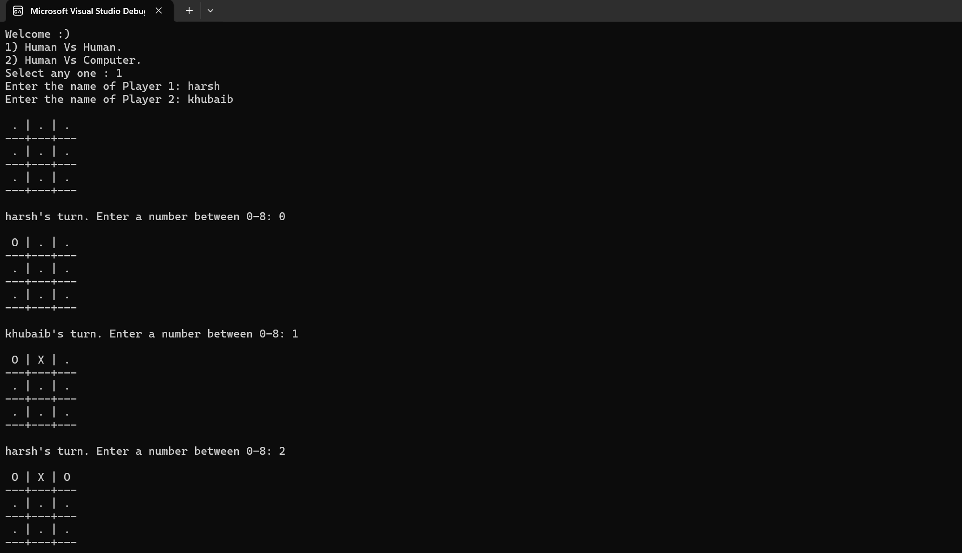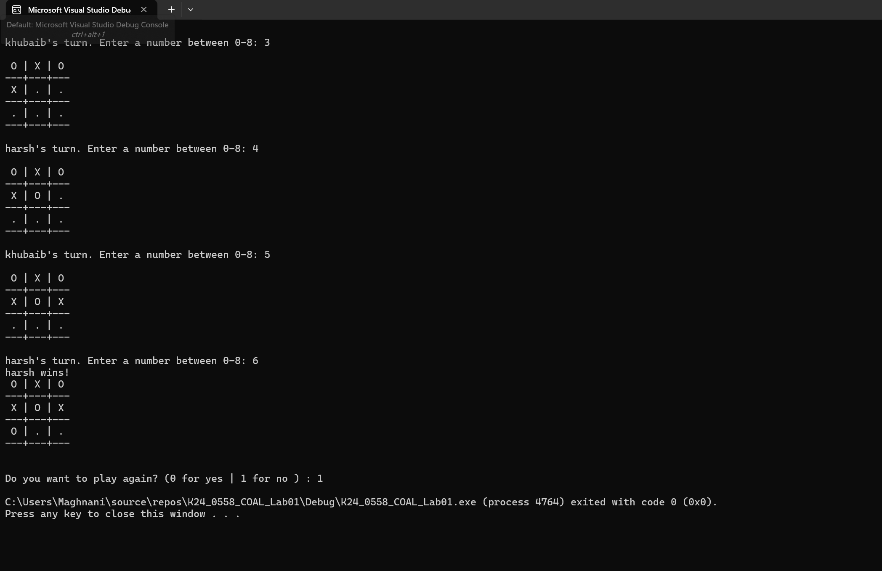

Testing & Validation
Test cases included:
- Filling entire board without wins → correctly outputs Draw
- Human forming horizontal, vertical, diagonal → correctly detects win
- Computer forced-win scenarios → AI finds winning move
- Human near-win scenarios → AI successfully blocks human
- Invalid input (negative / >8) → “Invalid input” message
- Occupied cell selection → “Cell already taken” message
All tests executed successfully.

7. Conclusion
Summary of Findings
The project demonstrates that even a simple game like Tic-Tac-Toe becomes a deep learning exercise when built in assembly. We successfully implemented:
- Full game logic
- Human VS Computer decision-making
- Memory-level grid updates
- Complex validations
- Clean I/O handling
—all without using any high-level constructs.
Final Remarks
This project strengthened understanding of:
- Low-level control flow
- Register operations
- Manual array indexing
- Procedure design
- Algorithm translation from high-level logic to assembly

